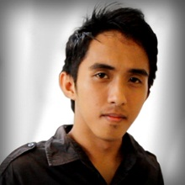Lucky Cristerson C. Tan

1482 East Capitol Hills, Brgy. Capitol Site, Cebu City

Mobile Number: 0942-3802026  
E-mail Address: [LCTPhantasm@yahoo.com](mailto:LCTPhantasm@yahoo.com)  
facebook.com/LCTheArtist

**PERSONALDATA**

Age : 21 years old

Date of Birth : August 14, 1992

Place of Birth : Cebu City

Gender : Male

Civil Status : Single

Nationality : Filipino

Religion : Catholic

Parents : Mr. Crisostomo A. Tan (Deceased)

: Mrs. Maria Teresa C. Tan

**EDUCATIONAL BACKGROUND**

Tertiary : Associate in Computer Technology – Major in Animation

: University of Cebu – Main Campus

: Sanciangko St., Cebu City

: 2009 (Undergraduate)

Secondary : University of Cebu – Main Campus

: Sanciangko St., Cebu City

: 2009 (Graduated)

Grade School : Subangdaku Elementary School

: M.J. Cuenco Ave., Wireless Subangdaku, Mandaue City

: 2005 (Graduated)

**AFFILIATION**

Paint Spill Organization

2010 – Present

University of Cebu – Main Campus

Member (Since 2010 – Present)

Math Club

2008 – Present

University of Cebu – Main Campus

Member (Since 2008 – 2009)

**WORKING EXPERIENCE**

H Graphics

Graphic Artist

2 Months Experience

May 2010 and May 2011

Dunkin’ Donuts

Service Crew / Cashier

4 Months of Experience

December 2011 – April 2012

Freelance Artist

Illustration, Multimedia, Motion Graphics, Video Editing

April 2012 – Present

**CHARACTER REFERENCES**

Noel Quijada Jr.

Concept Artist and Colourist  
S2 Pictures Ltd, HK

09224566327

Ronnie Abejero

Graphic Artist

Red Tag Printing Press

09224453786

Kathleen Key Alipin

Office Secretary

Quest Land Builders and Developers

09434220294



**ATTENTION**

Dear Madam/Sir;

To broaden my knowledge and enhance my craft as I practice my skill in a company that offers opportunities not only their clients but also to their employees.

I am Lucky Cristerson C. Tan, 21 years of age, a hardworking person, can work in minimum supervision and can work under pressure. I am also flexible in learning different kind of skills, also flexible in dealing with different kinds of people and willing to learn new things that can help achieve the company’s goal and to also have self-improvement. A chance and consideration would enable me to mix these varied experiences of mine in order to learn more about the details of the position open in accordance with company’s policy and standards.

Enclosed are my resume for ready reference & perusal.

I will be very glad if you consider my application. Rest assured I could handle the responsibilities.

I am hoping for your response.

Thank You.

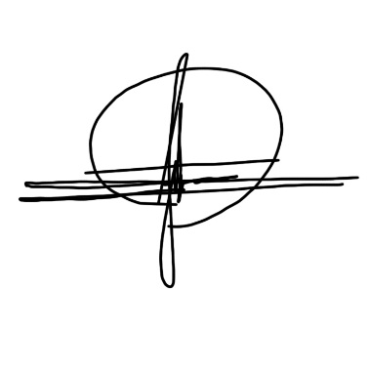

Very Respectfully Yours;

_________________________

Lucky Cristerson C. Tan